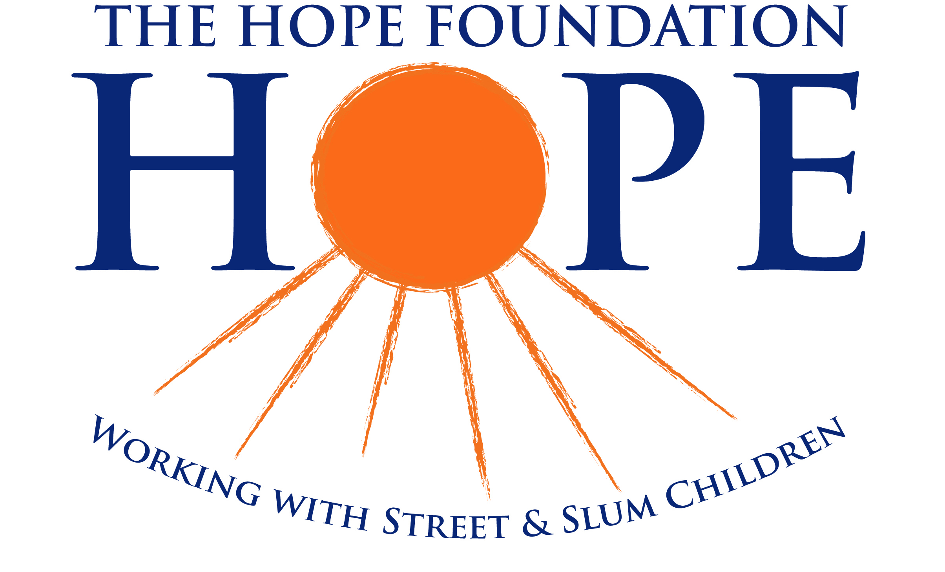
The Hope Foundation
Silverdale Grove,
Ballinlough,
Cork
Ireland
Tel: 00353-21-4292990
Fax: 00353-21-4293432
Email: eunice@hopefoundation.ie
www.hopefoundation.ie
Charity Reg No: CHY 13237
Charitable Co. Limited by Guarantee Reg. No. 303111

‘Child Sponsorship Programme’
Banker’s Standing Order Form
A donation by standing order is a great way of providing us with regular support.
A donation of just €21 or more per month can be a great tax-back benefit to HOPE without costing you anything extra! (If your total contribution to HOPE exceeds €250 in a calendar year, we can claim back the tax you have already paid to Revenue. All you need to do is sign a CHY Tax Form which we can send to you.)
I, __________________________________________ (full name) wish to make a standing order payable to: HOPE, AIB Bank 66 South Mall, Cork. Account No. 50677089; Sort Code: 93-63-83, IBAN: IE11 AIBK 9363 8350 6770 89, BIC: AIBKIE2D
Amount: €__________________ Monthly Annually
Amount in words: ___________________________________________________________________________________
Preferred Start Date: Day_____________ Month____________________ Year_______________
Ref: (Account Holder’s Name) _______________________________________________________________________
My Details:
Name: ______________________________________________________________________________
Address: ____________________________________________________________________________________
____________________________________________________________________________________
Tel No: ________________________ Email: ________________________________________________________
My Bank Details; Please fill in all details below
Bank Name: ______________________________________________________________________
Bank Address: ______________________________________________________________________
Bank Account No: ___________________________________ Sort Code: _____________________________
IBAN No: __________________________________________________________________________________________
BIC: _______________________________________________________________________________________________
Please debit my/our account number and pay on the date(s) specified and the amount specified above to HOPE, until you receive further notice from me/us in writing.
Signature: _______________________________ Date: _______________________________

Thank you for helping HOPE

When completed please return this form to Hope Foundation, Silverdale Grove, Ballinlough, Cork. We will contact your bank.

